杨浦区 2021学年度第一学期初三期末质量检测

（满分140分，考试时间90分钟）

考生注意：本卷有7大题，共84小题。试题均釆用连续编号，所有答案务必按照规定在答 题纸上完成，做在试卷上不给分。

Part 1 Listening (第一部分 听力)

1. Listening comprehension （听力理解）（共 25 分）

A. Listen and choose the right picture （根据你听到的内容，选出相应的图片）（5分）

B. Listen to the dialogue and choose the best answer to the question you hear (根据你听到的

|  |  |  |  |
| --- | --- | --- | --- |
| 对话和问题，选出最恰当的答案） | | （5分） | |
| 6. A)S1.99. | B) $2.99. | C) $3.99, | D) S4.99. |
| 7. A) Teacher and student. | | B) Detective and assistant. | |

C) Policeman and suspect.

D) Reporter and eye witness.

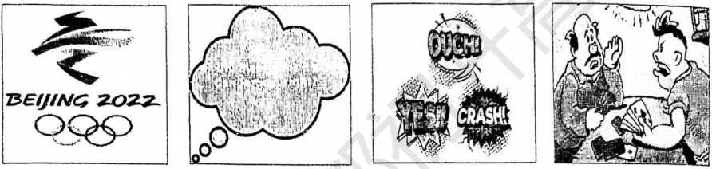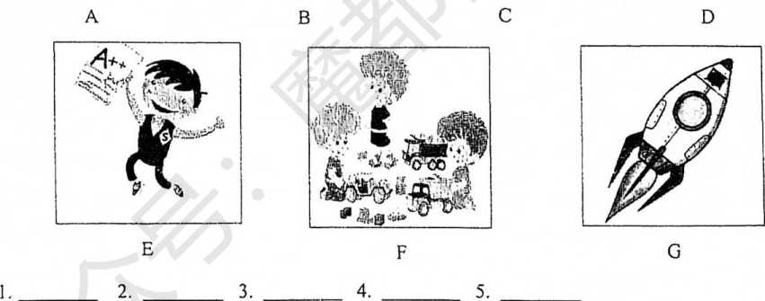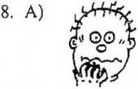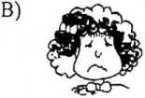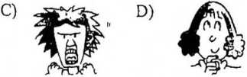

9. A) She saw a lilm without the man.

C) She went straight home after work.

B) She waited the man for a long time.

D) She left the movie to find rhe man.

10. A) The woman's computer broke down. B) The man refused to take the computer back.

C) Customers can't return items they dislike. D) Items can be returned with proof of purchase. C. Listen to the dialogue and tell whether the following statements are true or false (判断下 列句子是否符合你听到的对话内容，符合的用表示，不符合的用“F”表示)(5分)

11. The dialogue is between a waiter and a customer in a restaurant.

12. The customer was unhappy with her burger because it was cooked too long.

13. If the problem isn't solved, the customer will tell everyone on her social media.

14. Shawn refused to make a new burger because the customer ate most of the burger.

15. The customer will probably receive a formal apology from Shawn.

D. Listen to the passage and complete the following sentences (听短文，完成下列内容。毎 空格限填一词)(10分)

16. Superkilen, a park for the people, opened in .

17. People in the area come from all over the world, and the park shows their .

18. There are from Brazil for people to sit on and enjoy the nice views.

19. Black Market is a traditional and is busier than Red Plaza.

20. People like having picnics, doing sporls and in Green Park.

Part 2 Vocabulary and Grammar

（第二部分词汇和语法）

II. Choose the best answer (选择斌恰当的答案)(共15分)

21. Playing video games is not as as exercising.

A) good B) better C) best D) the best

22. Where are two dinner plates in the set? I can only find four.

A) other B) the other C) another D) others

23. At first, lhe students didn't seem with their new teacher. Now they love his lessons.

A) happy B) happily C) happiness D) unhappy

D) for24. The story of Robinson Crusoe is about a man living a desert island.

B) on C) at

amazing car! Is it powered by gasoline or electricity?

A) What B) How C) What a

26. My most memorable loy is a scooter. My sister and I practiced

A) push

27. Like all Greeks, she25. A) in

D) What an

with one foot every day. B) pushed C) pushing D) to push

the legend of Odysseus since childhood.

A) knows B) knew

28. The villagers are angry with the decision

A) close B) closedC) has known D) will know

the railway station.

C) to close D) closing

29. This method is rai'ely used in research,

D) isn*t the methodA) is it B) isn't it C) is the method

30. It was a cold winter's night. It but it was very windy.

D) wasn't rainingA) isn't raining B) didn't rain C) doesn't rain

31.1 don't have much of German history but I think choice A is most likely.

A) knowledge B) material C) joke D) interview

32.1 laughed when he fell in the mud, then I felt sorry for him.

A) and B) or C) so D) but

33. Do you find difficult to leam new skills like how to ride a skateboard?

A)/B) itC) this D) that

34. Bill Gates became interested in computers in those days they were not very common.

A) because B) although C) unless D) so that

35. - Kevin falls asleep in class every morning.

一 He be out late every night or maybe he works at night.

A) can B) need C) must D) should

HL Complete the following passage with the words or phrases in tbe box. Each can only be used once (将下列单词或词组填入空格。每空格限填一词，毎词只能填一次)供8分)

(A)

A. attention B. no longer C. competed D. compared E. conclusion

According to a recent study, dogs get *jealous* (嫉妒)just like humans do. In the study, two groins of dog owners were 36 . The authors of the study drew a 37 that dogs displayed more jealous behaviours when their owners showed affection toward another dog. Here are some signs of a jealous dog.

Pushing you away

Have you ever moved toward a member of your family, only to have your dog push you away? This

behavior is your dog*s way of telling you that it needs more 38 . *之* 『

Unkind actions

Your dog might show jealousy by barking, biting or even attacking others. f

Doing a trick

A jealous dog will perform tricks in hopes you* 11 look their way.

Going to the toilet indoors

If your dog *39* uses the toilet outdoors, this could be a sign they're feeling jealous,

(B)

A. calm B. basic C. faithfully D. depend on E. get along with

How do you deal with a jealous dog? Try one of the following tips.

Train your dog

Practice 40 commands like sit and stay. This will help you manage your 蔑就 働 dog when you notice bad behavior.

Encourage good behavior W

Give your dog treats and attention when it's 41 . This will help your dog 以丄 J" understand how you wont it to behave.

Make friends

Train your dog to 42 otliers. The dog park is a good place fbr your dog to practice playing with other dogs.

When a dog loves someone 43 , it's natural fbr it to feel jealous. Helping a jealous dog learn to share its favorite person won't happen in a day. But all the hard work will pay off when your dog starts to change its behavior. Like us, our dogs just want to feel loved.

**IV** Complete the sentences with the given words in their proper forms （用括号中所给单词 的适当形式完成下列句子。毎空格限填一洞）（共8分）

44. We went to the ±eatre last night. We had at the front row. （seat）

45. After Rita found herself locked on the floor, she soon had an escape plan, （two）

Part 3 Reading and Writing (第三部分 读写)

VI. Reading coniprehension (阅读理解)(共 50 分)

A. Choose the best answer (＜据所读内容，选择最恰当的答案)(12分)

46. *A* straight line is tlie distance between two points, （short）

47. Knowing that you are doing good and needed work can add to life, （mean）

48. Being kidnapped had been tlie most exprience of his life, （frighten）

49. The helicopter was damaged by lightning, but landed . （safe）

50. One of reading e-books is maybe the lighting or small screen, （advantage）

51. If they , the machines of the future will have longer and healthier lives, （success）

**V** Complete the following sentences as required （^.据所给要求，完成下列句子。毎空格限 填一词）（共14分）

52. He denied stealing the vase from the safe.（改为否定句）

He stealing the vase from the safe.

53. You can press the ESC button to exit the programme.（对划线部分提问）

can I press to exit the programme?

54.1 think online learning can be eye-opening for both teachers and students.（保*持句*意基本不变）

In , online learning can be eye-opening fbr both teachers and students.

55. In order to concentrate well, you must be relaxed.（保持句意基本不变）

Ybu must be relaxed you can concentrate well.

56. For along time, people recorded music on vinyl records.（改为被动语态）

For a long time, music on vinyl records.

57. Is the shoe depannent on this floor? Could you tell me?（合并成一句*）*

Could you tell me the shoe department on this floot?

58. more often, will die, waters, it, the plant, she, unless （连词成句*）*

p —

D —

3

S

Hany Hunker looks like an ordinary boy. He gOes to school with ordinaiy children, but they don't know who he really is： I： v daytime, Harry works hard at school. A ^nigbt, he's "Techno-Boy'*.

|  |  |
| --- | --- |
|  | n |
|  |  |

Techno-Boy is very intelligent. We buildstinyg^； 鼠，andhgt吁tg囂囂冨

Ichasing villains. They never escape.

' Techno-Boy can run fast, and he often leaps between high buildings when he's in a hurry, r- JHe can't fly, but he can levitate with his special 项rocket shoes. This is much quicker tha 噜 climbing the stairs! Techno-Boy has also got a： $ 专 special 'thought reader5 in his head, he can；

1 understand what his enemies are thinking.

"^Techno-Boy is half-boy and half-computer. Scientists 寵•瑚created him. They put a micro-computer inside his brain, 務 号and taught him to save the world. Every night, Techno- 酚 ‘Boy chases *villains* and protects the city. He doesn't need 铲 to sleep, and he's got some amazing super-powers. He can see in the dark, and he can catch a bullet in his hand. 鱒肖He wears a white Techno-Boy suit and special rocket ^^shoes. When Harry becomes Techno-Boy, he has red jeyes and he doesn't wear his glasses.

When Harry Hunker isn't Techno-Boy, he feels very lonely. Hairy has some amazing —adventures but his friends don't know his secret.

Sometimes he just wants to be ordinary.

59. The scene of Picture One is set .

A) at home B) at a cinema C) at school

60. The underlined word 'villains' in Picture Two means "

C) the rich

D) at a lab

A) heroes B) criminals

61. Techno-Boy is lonely because A) he looks different from others C) nobody in his school knows him

D) the innocent

B) he has lost his beloved families

D) his friends don't know his secret

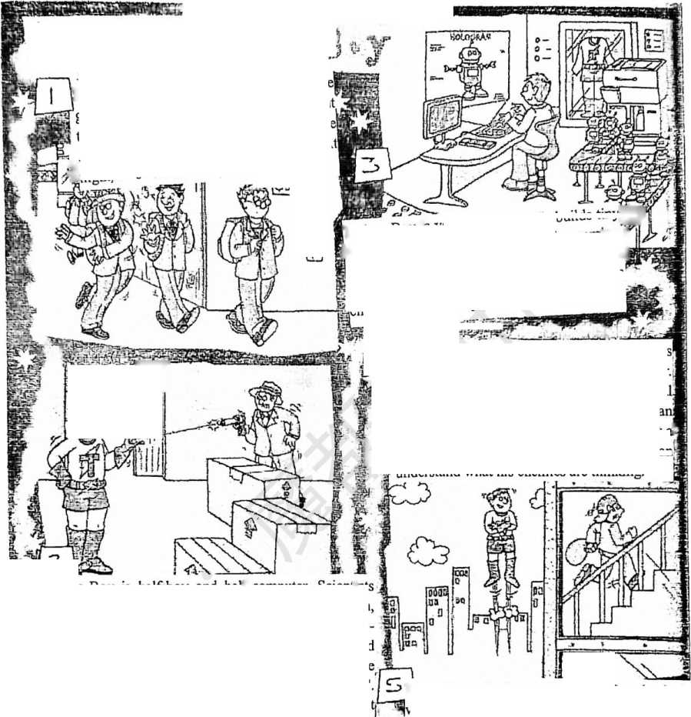

62. Techno-Boy is catching a bullet in Pictuie ,

A) One B) Two C) Tliree D) Four

63. Wliich of the following powers is NOT mentioned?

A) Lifting heavy objects. B) Making machines.

C) Reading people's minds. D) Seeing things in the dark.

64. The *theme* (主题)of the stoiy is

B) peace and war

D) courage and fearA) sti-ength vs. brain

C) good vs. evil

B. Choose the best answer and complete the passage (选择最恰当的选项完成短文)(12 分)

Looking back to when I was younger in the 1980s, I can remember dreaming of two inventions that I thought would change my world but were probably not likely to happen in my lifetime. One was a tiny 65 that I could cany around in my pocket and film moments whenever I had the opportunity. The other was something I could use to see and speak to people miles away.

It is unbelievable that during my adult life these two dreams have become a reality. And not even two separate inventions. Just one phone, small enough to keep in my pocket so that I _66 know it's there. I can video call or chat to friends and relatives, catch up with the latest news, watch videos of my favourite bands, check the weather forecast or send messages. I can shop as much as I want and even take a course in any subject I want... the 67 goes on.

Along with the Internet, the mobile phone must be the biggest change in technology ever. So why do many of us feel a little 68 how much time we spend on the phone in our lives? It's puzzling that the opportunities it has offered us fbr communication seem to have 69 the time we actually spend talking to each other. We are all used to seeing friends and families who are always looking at their screens and taking veiy little notice of those around them.

The mobile phone is here to stay and we have to find a way of dealing with the problems it might create. I believe these are challenges we have to solve independently rather than _70 something or someone else to come to our rescue. It's up to us to be careful about the time we spend online and remember that ifs good to talk with those sitting nearby. We can still feel amazed to have such a powerful piece of technology available when we need it.

|  |  |  |  |
| --- | --- | --- | --- |
| 65. A) radio | B) DVD-ROM | C) TV set | D) video camera |
| 66. A) especially | B) hardly | C) immediately | D) accurately |
| 67. A) list | B) legend | C) sale | D) memoiy |
| 68. A) sorry for | B) worried about | C) unaware of | D) wrong with |
| 69. A) changed | B) linked | C) increased | D) limited |
| 70. A) advising. | B) warning | C) expecting | D) allowing |

*C.* Fill in the blanks with proper words （在短文的空格内填入适当的词，使其通顺。毎空格 限填一词，首字母巳给）（14分）

One day，Jenny was taking her first art class at school. She was very excited.

The art teacher, Mrs Minton, told the chilchen to paint the flowers in a vase at the front ofthe

'Don't woiry if your painting doesn't look e__71 like the painting by the person next to you,' she said. 'The important thing is to paint what you see.'

Jenny worked very hard. She spent so long painting that her hand began to h 72 from holding the brush. She put the brush down for a moment to rest and looked at the painting next to hers.

'That's really good； she said to Carrie. Carrie's painting was small and neat. Every flower was just like the real flowers in the vase.

'Thanks,' said Came. She looked over at Jenny*s painting. 'Ohl What happened to yours?' 'What do you mean?* asked Jenny. She looked at her own painting. It was very different from Carrie's. It covered the whole page and the colors were b 73 than the real flowers.

,It looks like a big m 74 / said Carrie. 'Did you pour the paint?* ，No,' said Jenny, upset. 'I painted what I saw, just like Mrs Minton said.* 'It's OK, you know/ said Carrie. 'Not everyone is good at art.5 Mrs Minton heard what Canie said, and she came over to look at Jenny's work.

*Oh my,, said Mrs Minton. *1 think ifs wonderful, Jenny. It's so full of color and happiness., Jenny was very s 75 .

'But Mrs Minton, it doesn't look anything like the flowers you told us to draw.' Carrie said. *Maybe not to you, Carrie. Everyone sees different things when they look at the world? She showed them a picture in a book of a painting. *This is a picture an artist painted of his own face. This is how he saw h *76 '*

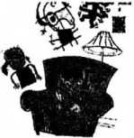'But... but... ifs just a few lines/ said Carrie. 'It doesn't look anything like a real person? Mrs Minton turned to Jenny. *You should read this book, Jenny. There are a lot of different kinds of paintings and one isn*t better than the other.,

That evening, Jenny read all about the famous artists. Some of their paintings were very s *77* . but she liked to look at them all.

'I'm going to be an artist when I grow up,' she said to her mother.

D. Answer the questions （根据短文内容回答下列问题）（12分）

Better Safe than Sorry

THE BEST WAY to deal with an emergency is to avoid one, if you can. Part Four of our ongoing series on crime prevention focuses on protecting your home against burglary. Sticky Fingers, an experienced burglar now serving a 6-year prison sentence, agreed to talk to our reporter.

Reporter: Sticky, what do you look for before burglarizing a house?

Fingers: Well, first, I make sure no one is home and no one is watching. I nose around neighbourhoods where people don't seem to know each other very well. That way, I won't be noticed. Next, I try to find a house where the people are on holiday and not likely to return soon. I do this by looking for houses with no lights on in the evening. Then I look at doorways. They're a sure *giveaway* （暴露）.Wlien newspapers, mail, and deliveries are piled 叩，］can tell that people have been away for days. I can even count how many days from the number of newspapers.

Reporter: 81 ?

Fingers: Well, usually ifs easy and effortless. Lots of times people leave a window open, or doors and windows unlocked. Then I just slip in. when I have to break in, I look fbr a *patio* （露台）door on the first floor. They usually have weak locks and you can force

them easily. I watch out fbr dogs, though. If I hear a dog barking, I go somewhere else.

**78.** The series is mainly about how to prevent crime, isn5t it?

**79.** How long will Sticky Fingers spend behind bars?

**80.** Where are newspapers, mail and deverlies usually piled up?

**81.** What best fits the blank?

**82.** What phrase can you use if you are advising someone to take action to avoid an emergency?

I would say "

**83.** Write at least 3 ways to protect your home against burglary. The first one has been done for you.

1） Get familiar with your neighbours. 2）

Vn. Writing （作文）（共 20 分）

**84.** Write at least 60 words according to the given situation.（根据以下情境写一篇不少于 60 个 词的短文，标点符号不占格）

学校以下各社团打算在活动周开展一些竞赛活动：

comics club （动漫社） computer club （电脑社）

school newspaper club （校报社） super brain club （最强大脑社）

debate club （辩论社） paper cutting club （剪纸社）

假设你是其中一个社团的干事Sandy,请拟一份通知告知你所在社团将要举行的活 动，内容包括：

1） 活动名称、目的

2） 活动时间、地点

3） 参加活动的相关要求

4） 奖项设置等

（注意：1.军玄中不得申现好名、,宓书等个人債皐,.吾则下手附。

2.照抄阅读语篇不得分。）

16. June 2012 17.various backgrounds 18.lovely chairs 19.town square 20.walking pets

Part 2 Vocabulary and grammar

**II.** 21. A 22. B 23. A 24. B 25. D 26. C 27. C

28. C 29. A 30. D

31. A 32. D 33. B 34. B 35. C

**III.** 36. D 37. E 38. A 39. B 40. B 41. A 42. E 43. C

**IV.** 44.seats 45.second 46.shortest 47.meaning

48.frightening 49.safely

50.disadvantage 51 .succeed

**V.** 52.didn,t deny 53.Which button 54.my opinion

55.so that 56.was recorded

57.whether/if...is 58. The plant will die unless she waters it more often.

Part 3 Reading and writing

**VI.** A) 59. C 60. B 61. D 62. B 63. A 64. C

B) 65. D 66. B 67. A 68. B 69. D 70. C

C) 71.exactly 72.hurt 73.brighter 74.mess

75.surprised 76.himself 77.strange

D) 78. Yes, it is.

79. Six years.

80. At doorways.

81. How do you break into a house?/ Is it easy or difficult to break into a house?

82. better safe than sorry

83. Possible answers: 1. Get

acquainted/familiar with your neighbours. 2. Be sure to close your windows and lock them.

3. Before leaving for holiday, stop delivery of newspapers and mail. 4. Leave at least one light on while you are away. 5. Strengthen the lock on your patio door. 6. Get a dog (that can bark) 顼^ 老师的英语旳冋